- Create project
django-admin startproject project10
- Create application within project
PS D:\Backup\Django9amMar\project10> python manage.py startapp app1
- Create model inside (models.py)

from django.db import models

# Create your models here.
class Student(models.Model):
rollno=models.IntegerField(primary_key=True)
name=models.CharField(max_length=20)
course=models.CharField(max_length=30)
fee=models.FloatField()

- Database configuration (settings.py)

DATABASES = {
'default': {
'ENGINE': 'django.db.backends.mysql',
'NAME': 'database10',
'USER':'root',
'PASSWORD':'root',
'HOST':'localhost',
'PORT':'3306',
}
}

- Install application (settings.py)

INSTALLED_APPS = [
'django.contrib.admin',
'django.contrib.auth',
'django.contrib.contenttypes',
'django.contrib.sessions',
'django.contrib.messages',
'django.contrib.staticfiles',
'app1',
]

- PS D:\Backup\Django9amMar\project10> python manage.py makemigrations
- PS D:\Backup\Django9amMar\project10> python manage.py migrate

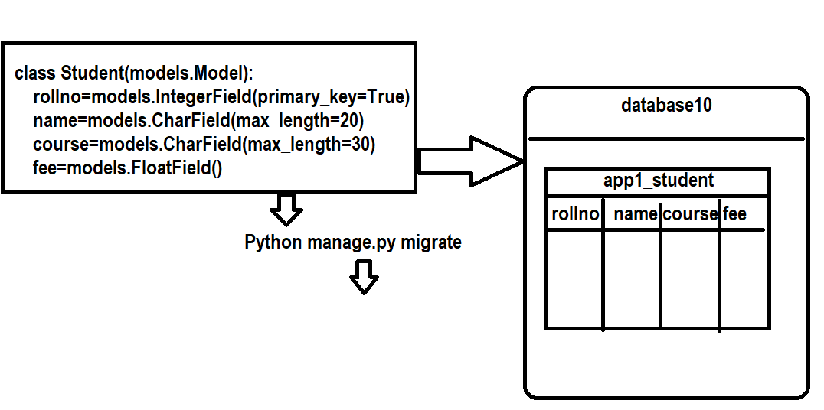

Inserting data into database table
Model provides various methods to insert data into database table
- Creating model instance/object
- Using create method of model manager

Inserting data by creating model instance/object

How to work with django shell?

PS D:\Backup\Django9amMar\project10> python manage.py shell
13 objects imported automatically (use -v 2 for details).

Ctrl click to launch VS Code Native REPL
Python 3.12.10 (tags/v3.12.10:0cc8128, Apr 8 2025, 12:21:36) [MSC v.1943 64 bit (AMD64)] on win32
Type "help", "copyright", "credits" or "license" for more information.
(InteractiveConsole)
>>>

>>> from app1.models import Student
>>> stud1=Student(rollno=1,name='naresh',course='python',fee=3000)
>>> stud1.save()
>>> stud2=Student(rollno=2,name='suresh',course='java',fee=2000)
>>> stud2.save()

save() method model, save changes or commit changes to database table.

Model manager?
Model manager is an object provided by model
Model manager provides methods to perform operations on model
Model manager is class level object, it is accessed with class name

Syntax: model-name.objects.method-name

Syntax:
model-name.objects.create(field-name=value,field-name=value,…)

create method of model manage create model instance and commit changes to database table.

>>> stud3=Student.objects.create(rollno=3,name='kishore',course='c++',fee=1000)
>>> print(stud3)
Student object (3)
>>> print(type(stud3))
<class 'app1.models.Student'>
>>> print(stud3.rollno,stud3.name,stud3.course,stud3.fee)
3 kishore c++ 1000
>>>

Views.py

from django.shortcuts import render
from app1.models import Student
from django.http import HttpResponse
# Create your views here.

def addstudent_view(request):
rollno=request.POST.get("rollno")
name=request.POST.get("name")
course=request.POST.get("course")
fee=request.POST.get("fee")
stud=Student.objects.create(rollno=int(rollno),
name=name,course=course,fee=float(fee))
response=HttpResponse("<h2>Student is Created</h2>")
return response

def addstud_temp(request):
response=render(request,"studentadd_temp.html")
return response

urls.py

from django.contrib import admin
from django.urls import path
from app1.views import addstud_temp,addstudent_view
urlpatterns = [
path('admin/', admin.site.urls),
path("",addstud_temp),
path("addstudview/",addstudent_view),

]

Settings.py

INSTALLED_APPS = [
'django.contrib.admin',
'django.contrib.auth',
'django.contrib.contenttypes',
'django.contrib.sessions',
'django.contrib.messages',
'django.contrib.staticfiles',
'app1',
]
TEMPLATES = [
{
'BACKEND': 'django.template.backends.django.DjangoTemplates',
'DIRS': [BASE_DIR/"templates"],
DATABASES = {
'default': {
'ENGINE': 'django.db.backends.mysql',
'NAME': 'database10',
'USER':'root',
'PASSWORD':'root',
'HOST':'localhost',
'PORT':'3306',
}
}

Studentadd_temp.html

<!DOCTYPE html>
<html lang="en">
<head>
<meta charset="UTF-8">
<meta name="viewport" content="width=device-width, initial-scale=1.0">
<title>Document</title>
</head>
<body>
<form action="/addstudview/" method="POST">
{%csrf_token%}
<table border="2" width="100%">
<tr>
<td>Rollno</td>
<td><input type=text name="rollno"></td>
</tr>
<tr>
<td>StudentName</td>
<td><input type=text name="name"></td>
</tr>
<tr>
<td>StudentCourse</td>
<td><input type=text name="course"></td>
</tr>
<tr>
<td>StudentFee</td>
<td><input type=text name="fee"></td>
</tr>
<tr>
<td><input type="submit" value="create"></td>
<td><input type="reset" value="clear"></td>
</tr>

</table>

</form>
</body>
</html>

Models.py

from django.db import models

# Create your models here.
class Student(models.Model):
rollno=models.IntegerField(primary_key=True)
name=models.CharField(max_length=20)
course=models.CharField(max_length=30)
fee=models.FloatField()

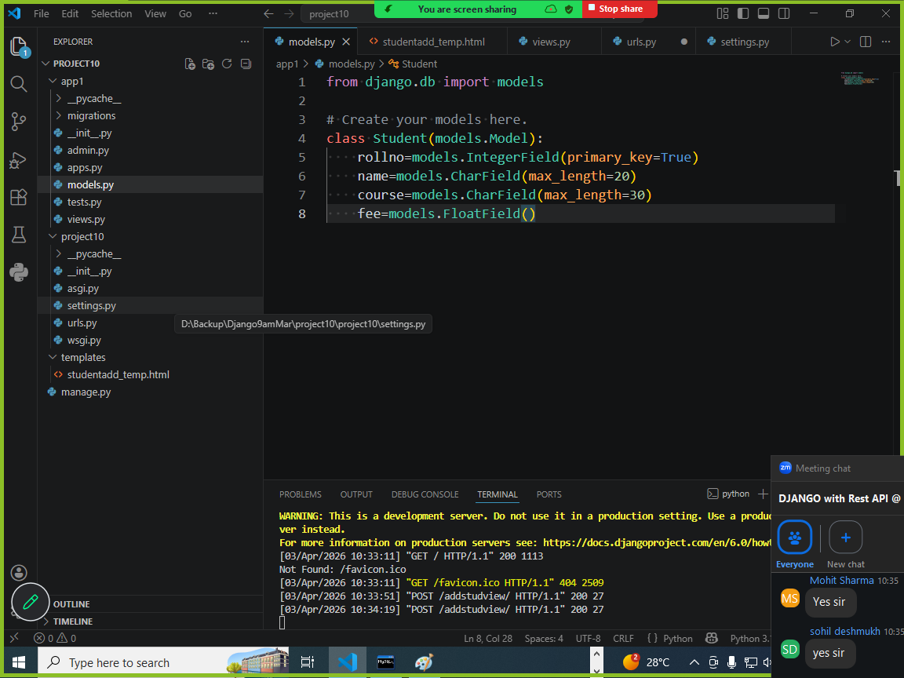

Reading data from database table

Model manager provides various methods to read data from database table.

- get()
- all()
- filter()

